Triangle Altitude
# Source: AI Source: Provided by: [Data Path: Persons Table -> ID Column: 1, Name_En Column: Motasem Essam] -> From: [ChatGPT] on [7/25/2026]

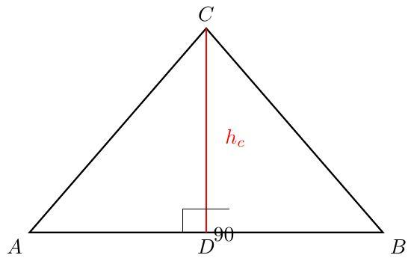
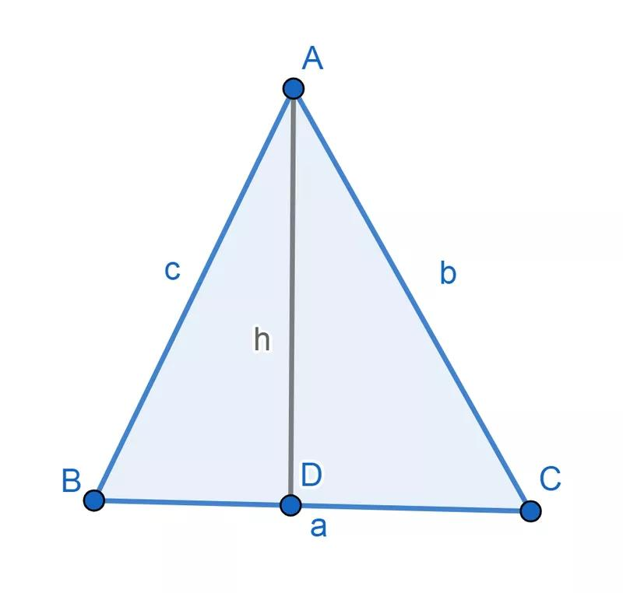
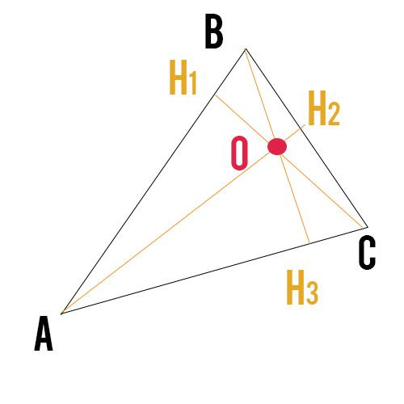

Definition
# Source: AI Source: Provided by: [Data Path: Persons Table -> ID Column: 1, Name_En Column: Motasem Essam] -> From: [ChatGPT] on [7/25/2026]
A triangle altitude is a perpendicular line segment drawn from a vertex of a triangle to the line containing the opposite side.
In other words, an altitude:
- Starts at a vertex.
- Meets the opposite side, or its extension.
- Forms a right angle (${90}^{∘}$) with that line.
For triangle $ABC$, if $D$ is the point where the altitude from $A$ meets $BC$, then:
$$\boxed{AD⟂BC}$$
Therefore:
$$∠ADB={90}^{∘}$$
and
$$∠ADC={90}^{∘}$$

Purpose
# Source: AI Source: Provided by: [Data Path: Persons Table -> ID Column: 1, Name_En Column: Motasem Essam] -> From: [ChatGPT] on [7/25/2026]
The altitude is used to:
- Determine the height of a triangle.
- Calculate the area of a triangle.
- Identify the orthocenter.
- Divide a triangle into right triangles.
- Solve problems involving perpendicular distances.
- Establish relationships between sides and angles.

Basic Configuration
# Source: AI Source: Provided by: [Data Path: Persons Table -> ID Column: 1, Name_En Column: Motasem Essam] -> From: [ChatGPT] on [7/25/2026]
For triangle $ABC$, draw an altitude from vertex $A$ to side $BC$.

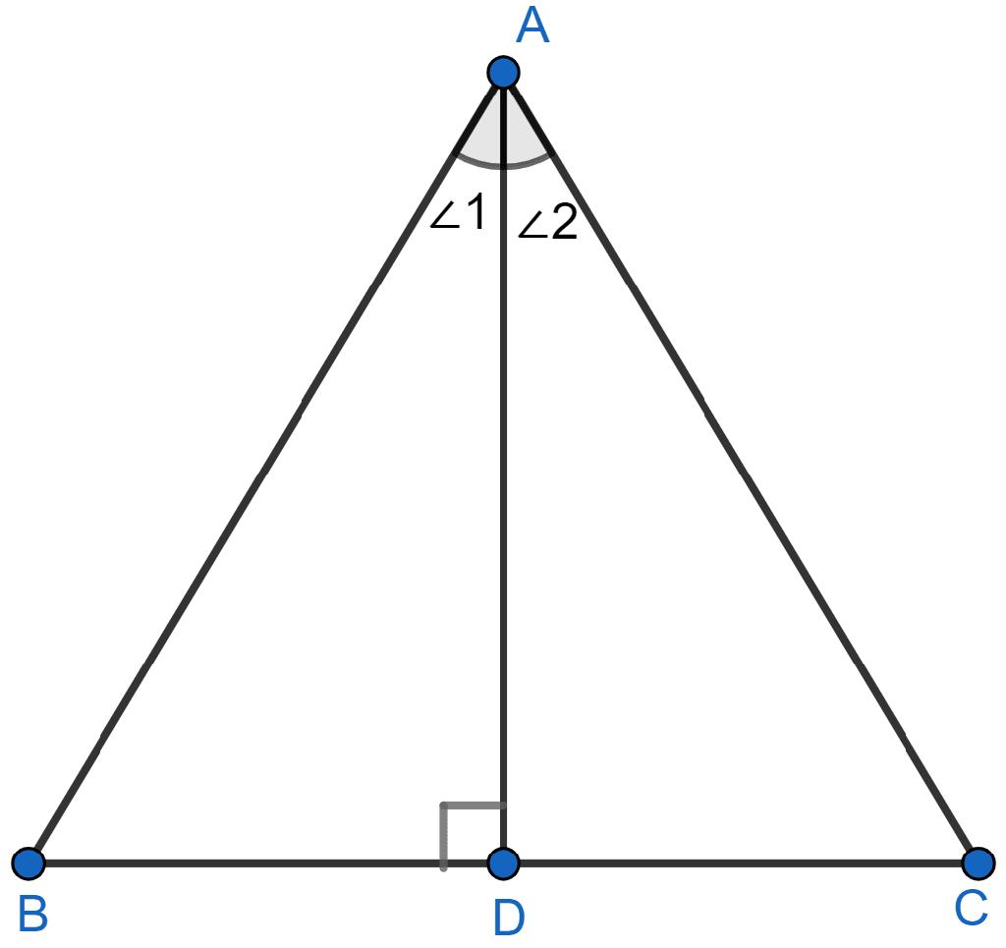
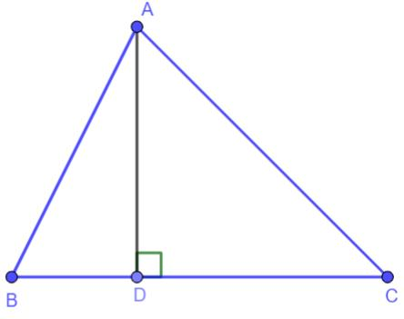
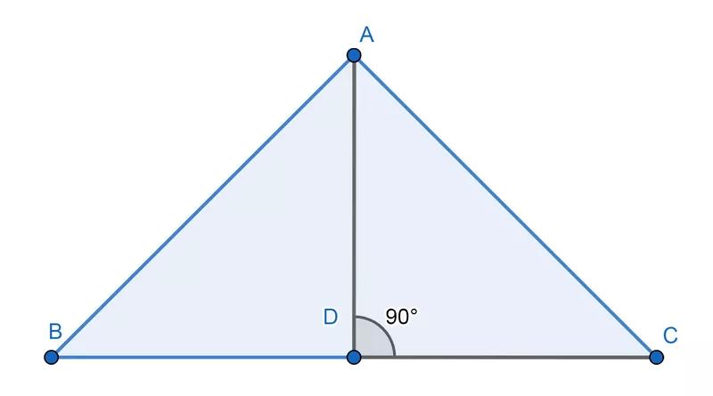
If $D$ is the foot of the altitude:
$$\boxed{AD⟂BC}$$
The segment $AD$ is called the altitude, while $D$ is called the foot of the altitude.

Number of Altitudes
# Source: AI Source: Provided by: [Data Path: Persons Table -> ID Column: 1, Name_En Column: Motasem Essam] -> From: [ChatGPT] on [7/25/2026]
Every triangle has exactly three altitudes.
They originate from the three vertices:
- Altitude from $A$
- Altitude from $B$
- Altitude from $C$
They are commonly represented as:
$$h_{a}, h_{b}, h_{c}$$
where:
- $h_{a}$ is the altitude to side $a=BC$
- $h_{b}$ is the altitude to side $b=CA$
- $h_{c}$ is the altitude to side $c=AB$

Mathematical Representation
# Source: AI Source: Provided by: [Data Path: Persons Table -> ID Column: 1, Name_En Column: Motasem Essam] -> From: [ChatGPT] on [7/25/2026]
For altitude $h_{a}$:
$$\boxed{h_{a}⟂BC}$$
The area of the triangle is:
$$\boxed{A=\frac{1}{2}bh}$$
Therefore, if the base is $a$:
$$A=\frac{1}{2}ah_{a}$$
Solving for the altitude:
$$\boxed{h_{a}=\frac{2A}{a}}$$
Similarly:
$$\boxed{h_{b}=\frac{2A}{b}}$$
$$\boxed{h_{c}=\frac{2A}{c}}$$

Examples

Example 1: Identifying an Altitude
# Source: AI Source: Provided by: [Data Path: Persons Table -> ID Column: 1, Name_En Column: Motasem Essam] -> From: [ChatGPT] on [7/25/2026]
Suppose $AD$ is drawn from vertex $A$ to $BC$, and:
$$∠ADB={90}^{∘}$$
Therefore:
$$AD⟂BC$$
So:
$$\boxed{AD\text{ is an altitude}}$$

Example 2: Finding the Altitude from Area
# Source: AI Source: Provided by: [Data Path: Persons Table -> ID Column: 1, Name_En Column: Motasem Essam] -> From: [ChatGPT] on [7/25/2026]
Suppose a triangle has:
$$A=48{\text{ cm}}^{2}$$
and base:
$$b=12\text{ cm}$$
Using:
$$A=\frac{1}{2}bh$$
we get:
$48=\frac{1}{2}(12)h$ $48=6h$ $h=8$
Therefore:
$$\boxed{h=8\text{ cm}}$$

Example 3: Finding Area Using an Altitude
# Source: AI Source: Provided by: [Data Path: Persons Table -> ID Column: 1, Name_En Column: Motasem Essam] -> From: [ChatGPT] on [7/25/2026]
Suppose:
$$b=15\text{ cm}$$
and:
$$h=10\text{ cm}$$
Then:
$A=\frac{1}{2}bh$ $A=\frac{1}{2}(15)(10)$ $A=75$
Therefore:
$$\boxed{A=75{\text{ cm}}^{2}}$$

Altitudes According to Triangle Type
# Source: AI Source: Provided by: [Data Path: Persons Table -> ID Column: 1, Name_En Column: Motasem Essam] -> From: [ChatGPT] on [7/25/2026]
The position of an altitude depends on the type of triangle.

1. Acute Triangle
# Source: AI Source: Provided by: [Data Path: Persons Table -> ID Column: 1, Name_En Column: Motasem Essam] -> From: [ChatGPT] on [7/25/2026]
In an acute triangle, all three altitudes lie inside the triangle.

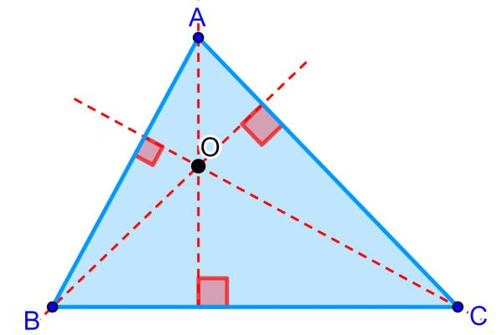
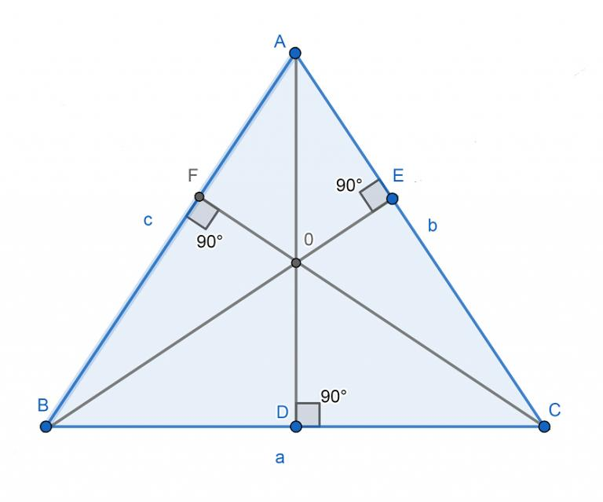
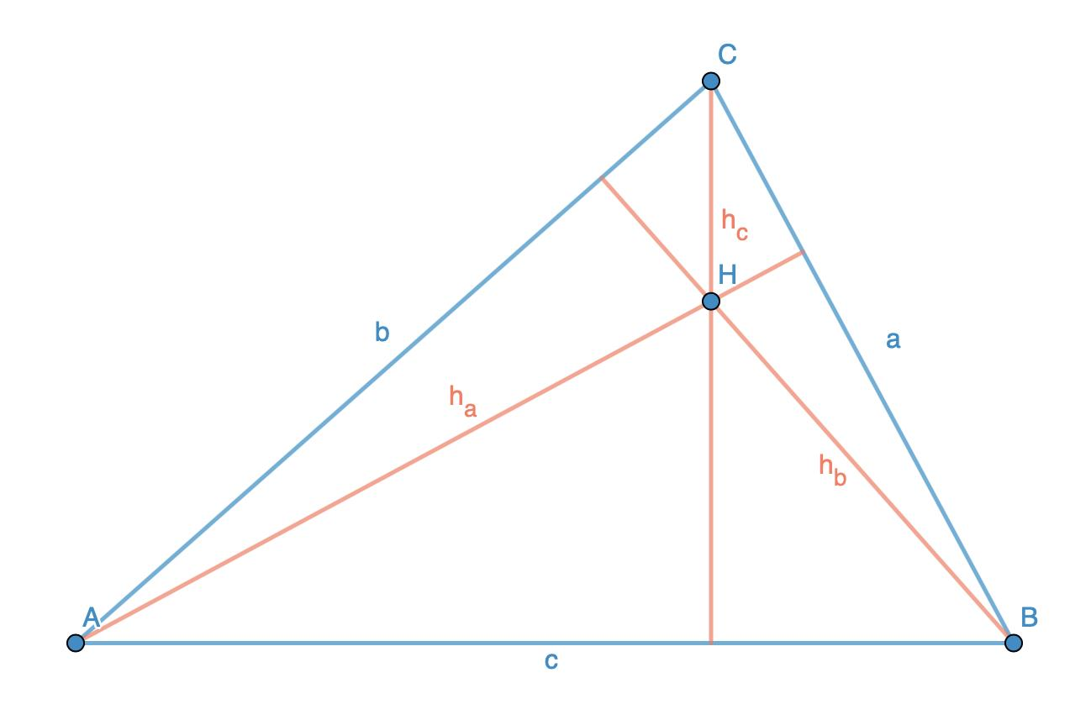
The three altitudes intersect inside the triangle.

2. Right Triangle
# Source: AI Source: Provided by: [Data Path: Persons Table -> ID Column: 1, Name_En Column: Motasem Essam] -> From: [ChatGPT] on [7/25/2026]
In a right triangle, two sides are already perpendicular.
Therefore, two sides of the triangle themselves act as altitudes.

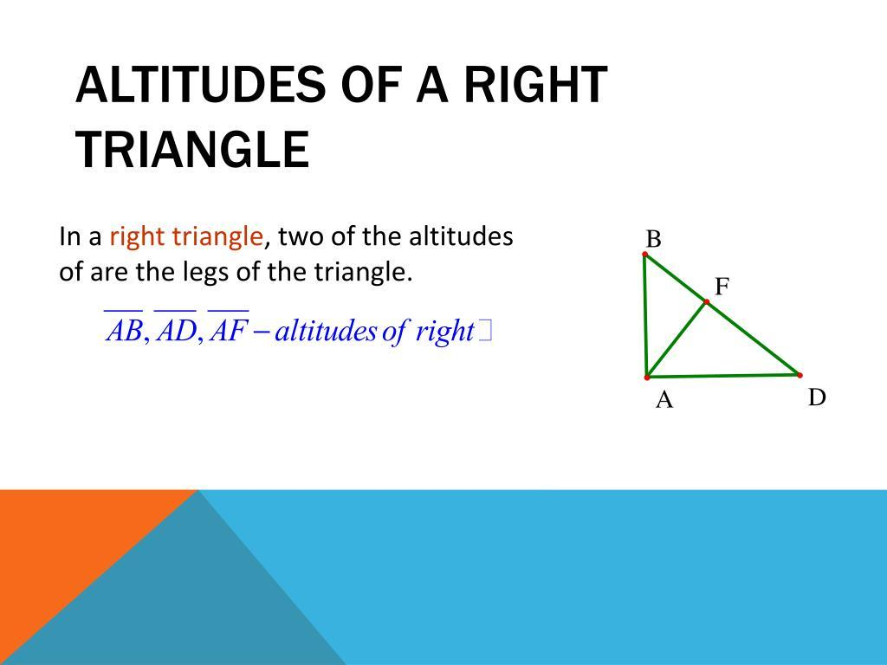
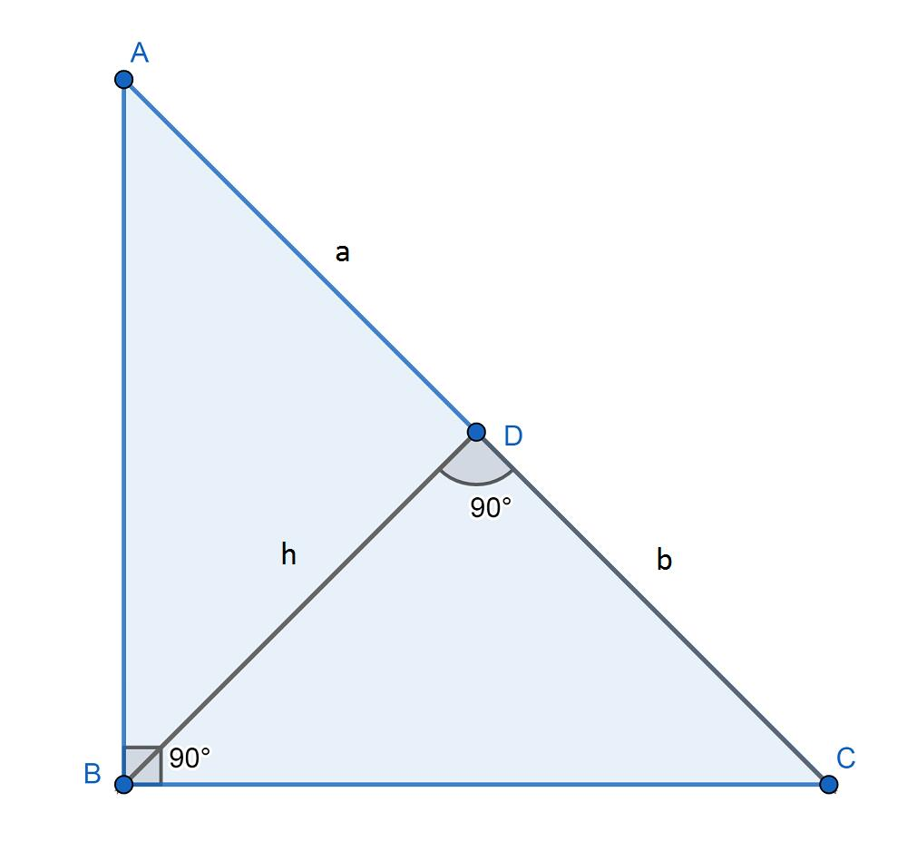
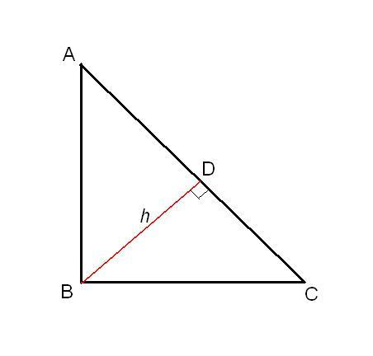
For a right triangle with right angle at $A$:
$$AB⟂AC$$
Therefore:
- $AB$ is an altitude to $AC$.
- $AC$ is an altitude to $AB$.
The third altitude is drawn from $A$ to the hypotenuse $BC$.

3. Obtuse Triangle
# Source: AI Source: Provided by: [Data Path: Persons Table -> ID Column: 1, Name_En Column: Motasem Essam] -> From: [ChatGPT] on [7/25/2026]
In an obtuse triangle, some altitudes fall outside the triangle.

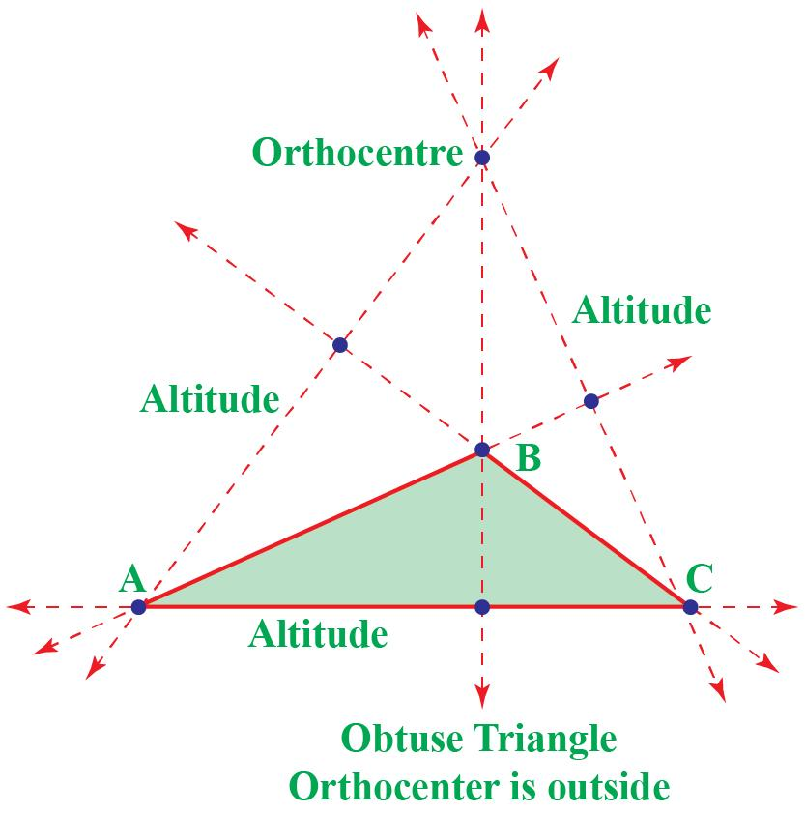
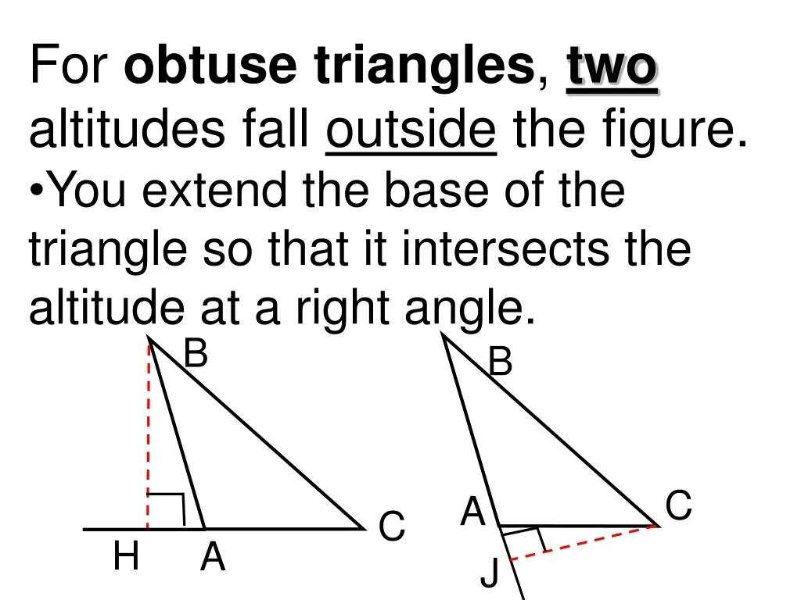
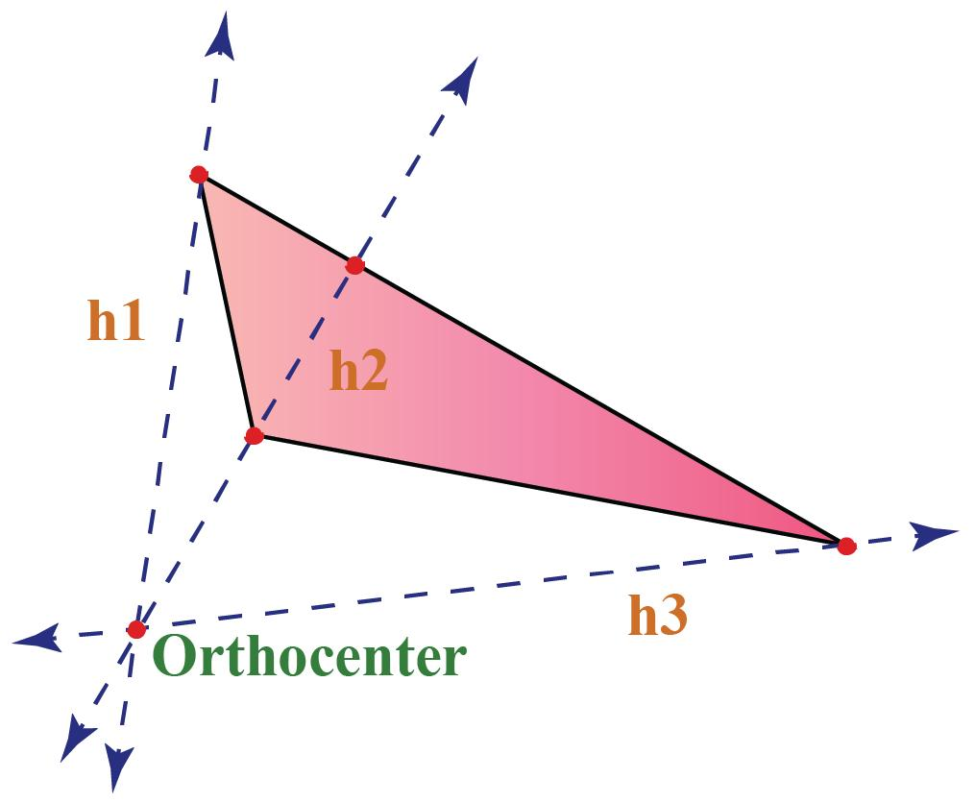
This happens because the opposite side must sometimes be extended to create the perpendicular line.

Foot of the Altitude
# Source: AI Source: Provided by: [Data Path: Persons Table -> ID Column: 1, Name_En Column: Motasem Essam] -> From: [ChatGPT] on [7/25/2026]
The point where an altitude meets the opposite side or its extension is called the foot of the altitude.
For example:
$$AD$$
is the altitude, and:
$$D$$
is its foot.
Thus:
$$\boxed{AD⟂BC}$$
with $D$ being the foot of the altitude.

Orthocenter
# Source: AI Source: Provided by: [Data Path: Persons Table -> ID Column: 1, Name_En Column: Motasem Essam] -> From: [ChatGPT] on [7/25/2026]
The three altitudes of a triangle are concurrent, meaning they intersect at one point.
This point is called the orthocenter.

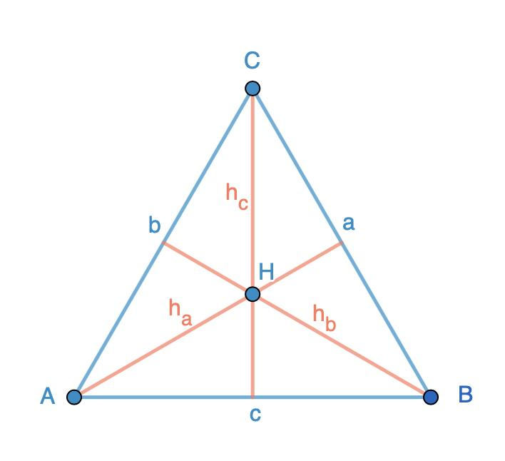
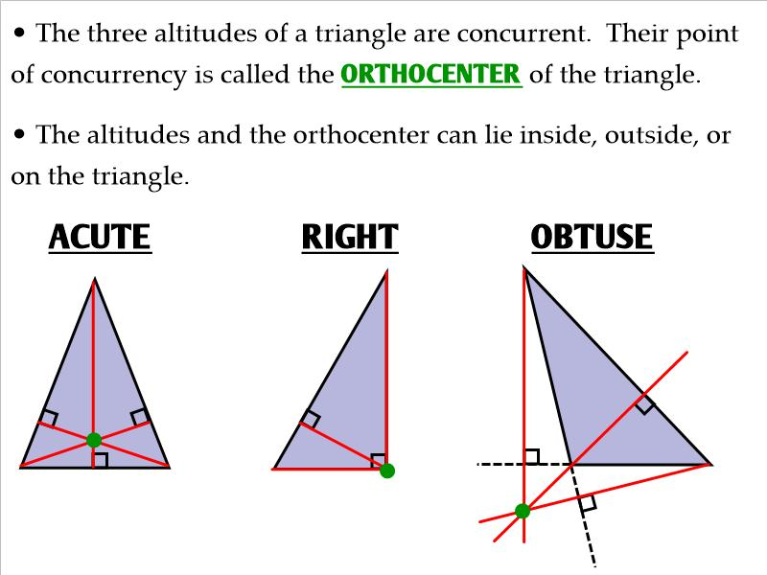
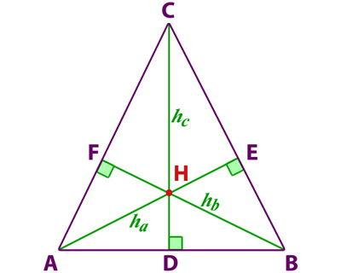
The orthocenter is usually labeled:
$$\boxed{H}$$
Therefore:
$$\boxed{\text{The three altitudes intersect at the orthocenter}}$$

Location of the Orthocenter
# Source: AI Source: Provided by: [Data Path: Persons Table -> ID Column: 1, Name_En Column: Motasem Essam] -> From: [ChatGPT] on [7/25/2026]
The location of the orthocenter depends on the triangle.
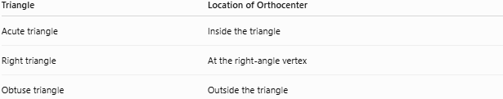
Triangle | Location of Orthocenter
Acute triangle | Inside the triangle
Right triangle | At the right-angle vertex
Obtuse triangle | Outside the triangle

Altitude and Area
# Source: AI Source: Provided by: [Data Path: Persons Table -> ID Column: 1, Name_En Column: Motasem Essam] -> From: [ChatGPT] on [7/25/2026]
The altitude is especially important because it represents the height corresponding to a chosen base.
For example:
$$\boxed{A=\frac{1}{2}bh}$$
where:
- $A$ = area
- $b$ = chosen base
- $h$ = altitude corresponding to that base
Important
The altitude must be perpendicular to the chosen base.
You cannot use an arbitrary side as the height unless it is perpendicular to the chosen base.

Altitude Length Using Heron's Formula
# Source: AI Source: Provided by: [Data Path: Persons Table -> ID Column: 1, Name_En Column: Motasem Essam] -> From: [ChatGPT] on [7/25/2026]
If the three side lengths are known, the altitude can also be found using the area.
First calculate the semiperimeter:
$$s=\frac{a+b+c}{2}$$
Then use Heron's formula:
$$A=\sqrt{s(s-a)(s-b)(s-c)}$$
Once the area is known:
$$\boxed{h_{a}=\frac{2A}{a}}$$

Example 4: Finding an Altitude from Three Sides
# Source: AI Source: Provided by: [Data Path: Persons Table -> ID Column: 1, Name_En Column: Motasem Essam] -> From: [ChatGPT] on [7/25/2026]
Suppose:
$$a=5, b=6, c=7$$
First:
$$s=\frac{5+6+7}{2}=9$$
Using Heron's formula:
$A=\sqrt{9(9-5)(9-6)(9-7)}$
$A=\sqrt{9(4)(3)(2)}$
$$A=\sqrt{216}=6\sqrt{6}$$
The altitude to side $a=5$ is:
$$h_{a}=\frac{2(6\sqrt{6})}{5}$$
Therefore:
$$\boxed{h_{a}=\frac{12\sqrt{6}}{5}}$$
approximately:
$$\boxed{h_{a}≈5.88}$$

Altitude vs. Median
# Source: AI Source: Provided by: [Data Path: Persons Table -> ID Column: 1, Name_En Column: Motasem Essam] -> From: [ChatGPT] on [7/25/2026]
An altitude and a median are different concepts.
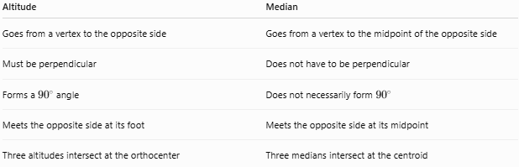
Altitude | Median
Goes from a vertex to the opposite side | Goes from a vertex to the midpoint of the opposite side
Must be perpendicular | Does not have to be perpendicular
Forms a ${90}^{∘}$ angle | Does not necessarily form ${90}^{∘}$
Meets the opposite side at its foot | Meets the opposite side at its midpoint
Three altitudes intersect at the orthocenter | Three medians intersect at the centroid

Special Case
# Source: AI Source: Provided by: [Data Path: Persons Table -> ID Column: 1, Name_En Column: Motasem Essam] -> From: [ChatGPT] on [7/25/2026]
In an isosceles triangle, the median from the vertex between the equal sides is also an altitude.
In an equilateral triangle:
$$\boxed{\text{Median}=\text{Altitude}=\text{Angle Bisector}}$$

Altitude vs. Angle Bisector
# Source: AI Source: Provided by: [Data Path: Persons Table -> ID Column: 1, Name_En Column: Motasem Essam] -> From: [ChatGPT] on [7/25/2026]
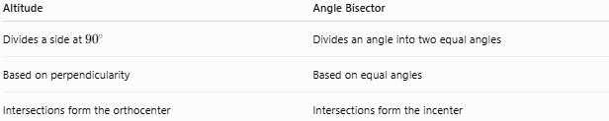
Altitude | Angle Bisector
Divides a side at ${90}^{∘}$ | Divides an angle into two equal angles
Based on perpendicularity | Based on equal angles
Intersections form the orthocenter | Intersections form the incenter
An altitude does not generally bisect the angle at its vertex.

Altitude vs. Midsegment
# Source: AI Source: Provided by: [Data Path: Persons Table -> ID Column: 1, Name_En Column: Motasem Essam] -> From: [ChatGPT] on [7/25/2026]
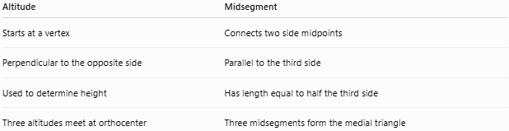
Altitude | Midsegment
Starts at a vertex | Connects two side midpoints
Perpendicular to the opposite side | Parallel to the third side
Used to determine height | Has length equal to half the third side
Three altitudes meet at orthocenter | Three midsegments form the medial triangle

Special Properties

Equilateral Triangle
# Source: AI Source: Provided by: [Data Path: Persons Table -> ID Column: 1, Name_En Column: Motasem Essam] -> From: [ChatGPT] on [7/25/2026]
For an equilateral triangle:
$$\boxed{\text{All three altitudes are also medians}}$$
They are also:
- Angle bisectors
- Perpendicular bisectors
- Lines of symmetry
All three meet at the same point.

Isosceles Triangle
# Source: AI Source: Provided by: [Data Path: Persons Table -> ID Column: 1, Name_En Column: Motasem Essam] -> From: [ChatGPT] on [7/25/2026]
In an isosceles triangle, the altitude from the vertex between the equal sides is also:
$$\boxed{\text{Median}}$$
and:
$$\boxed{\text{Angle Bisector}}$$
and:
$$\boxed{\text{Perpendicular Bisector of the Base}}$$

Real-World Applications
# Source: AI Source: Provided by: [Data Path: Persons Table -> ID Column: 1, Name_En Column: Motasem Essam] -> From: [ChatGPT] on [7/25/2026]
Triangle altitudes are useful in:
- Architecture — determining the height of triangular structures.
- Engineering — analyzing triangular components.
- Construction — calculating vertical and perpendicular dimensions.
- Surveying — determining distances and heights.
- Physics — calculating areas and geometric heights.
- Computer graphics — processing triangular meshes.
- Land measurement — calculating triangular regions.

Applications
# Source: AI Source: Provided by: [Data Path: Persons Table -> ID Column: 1, Name_En Column: Motasem Essam] -> From: [ChatGPT] on [7/25/2026]
Triangle altitudes are commonly used for:
- Calculating triangle area.
- Finding unknown heights.
- Finding perpendicular distances.
- Locating the orthocenter.
- Solving right-triangle problems.
- Proving geometric relationships.
- Coordinate geometry.
- Trigonometry.

Advantages
# Source: AI Source: Provided by: [Data Path: Persons Table -> ID Column: 1, Name_En Column: Motasem Essam] -> From: [ChatGPT] on [7/25/2026]
- Provides a direct definition of triangle height.
- Makes the area formula possible.
- Works with every type of triangle.
- Helps locate the orthocenter.
- Creates right triangles that simplify calculations.
- Has applications in geometry, trigonometry, engineering, and physics.

Limitations
# Source: AI Source: Provided by: [Data Path: Persons Table -> ID Column: 1, Name_En Column: Motasem Essam] -> From: [ChatGPT] on [7/25/2026]
- An altitude does not necessarily lie inside the triangle.
- In an obtuse triangle, the altitude may meet an extension of the opposite side.
- An altitude does not generally bisect the opposite side.
- An altitude does not generally bisect the vertex angle.
- The altitude changes depending on which side is chosen as the base.

Key Points
# Source: AI Source: Provided by: [Data Path: Persons Table -> ID Column: 1, Name_En Column: Motasem Essam] -> From: [ChatGPT] on [7/25/2026]
- An altitude is a perpendicular segment from a vertex to the line containing the opposite side.
- Every triangle has three altitudes.
- The point where an altitude meets the opposite side is its foot.
- The three altitudes intersect at the orthocenter.
- The area formula is:
$$\boxed{A=\frac{1}{2}bh}$$
- Therefore:
$$\boxed{h=\frac{2A}{b}}$$
- In an acute triangle, all altitudes lie inside.
- In a right triangle, two sides themselves are altitudes.
- In an obtuse triangle, some altitudes lie outside.
- An altitude is not the same as a median in general.
- In an equilateral triangle, the altitude is also a median, angle bisector, and perpendicular bisector.

Conclusion
# Source: AI Source: Provided by: [Data Path: Persons Table -> ID Column: 1, Name_En Column: Motasem Essam] -> From: [ChatGPT] on [7/25/2026]
A triangle altitude is a perpendicular segment drawn from a vertex to the line containing the opposite side. The three altitudes of every triangle meet at the orthocenter. Altitudes are fundamental for calculating triangle area, determining heights and perpendicular distances, and studying important relationships among triangle centers. Unlike a median, an altitude is defined by perpendicularity, not by dividing the opposite side into equal parts.
Do you like this personality?
